 | THE ROYAL BRITISH LEGION  Paris Branch Newsletter - October 2013
Chairman’s Report
You will find in this edition reference to a number of social events planned by Joan Hicks. Here also Mark Yates takes the opportunity to remind us that it is the time of year for us to pay our subscriptions - by the end of October at the latest please. His form enables us to make a contribution at the same time to the Branch Poppy Appeal Fund as well as to the Branch General Fund. The latter meets our operating expenses.

May I draw your attention in particular to our traditional Coffee Morning, when we are the guests of Lady Ricketts at the Ambassador’s Residence on 29th October. By then our 2013 Poppy Appeal Campaign will be well advanced, and we look forward to assisting our new Poppy Appeal Organizer, Bridget Terrell, in every way possible. We are thrilled that she has accepted our invitation to take on this task, since she is uniquely qualified with her many contacts in the British Community.

Then of course we shall once more be organizing the Service of Remembrance on 11th November at the Cathédrale de Notre Dame de Paris at 3 p.m. We are pleased to announce that the Reverend Jim Cowie, Minister of the Scots Kirk, has agreed to act as our Branch Chaplain for this service, and we are deeply grateful to him for accepting our invitation.

Some of us attended the launch of Noreen Riols’s new book at W.H. Smith last week. With her delicious sense of humour she has chosen the title “The Secret Ministry of Ag. and Fish” ! Sub-title: “My Life in Churchill’s School for Spies”. It tells her story of working in the Special Operations Executive during the Second World War. You will find many references to Branch member Bob Maloubier, the ace saboteur in S.O.E. I am presently reading this book and it fills one with enormous respect for the courage of those young men and women who volunteered for such a dangerous role, with the highest possible risk of torture and execution. You may obtain a copy of the book at W.H. Smith of course.

I should like to draw your attention to the brilliant initiative of Grahame Warby, Roger and Janet’s son. He has undertaken to compile a collection of stories by Branch members of their service experience, principally but not exclusively in World War Two, as well as accounts from those of us who have memories as civilians from those days. He invites us to send our draft texts to him by e-mail at gwarby@cogencesearch.com. The deadline for your submissions is 31st October. The collection will be published and the net proceeds will go to RBL Paris Branch General Fund. So please do not hesitate to contact Grahame. Thank you so much Grahame for spotting this great fund-raising opportunity and for all the hard work that is going into it.

“We will remember them”
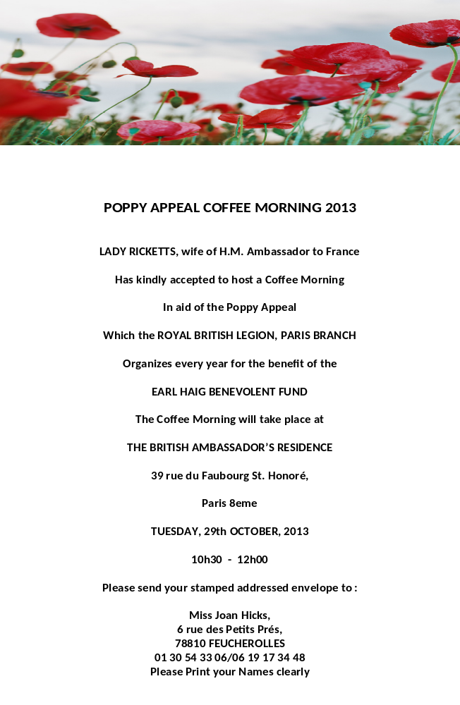
RBL Christmas lunch & Dinner

Joan Hicks, our Events Organiser, is trying to organise a Christmas lunch at the RBL in rue des Acacias and a Christmas Dinner most likely to be held at Fuecherolles Golf Club in Yvelines.

The cost of the lunch is €32 per person. Please book early.

Miss Hicks is hoping to organise a suitable Christmas dinner to include Christmas Pudding for a maximum cost of €35 - €40 per person. She is also trying to organise a free mini-bus for 8-10 people who might like to come to the dinner but live in Paris and do not have transport.

If you would like to attend either the lunch or dinner, please contact Joan Hicks on 01 30 54 33 06 or 06 19 17 34 48 or email joan.hicks@orange.fr Joan will be able to inform you of the correct cost and then ask you to send your cheque. Reservations for dinner by 15th October.

Please see the enclosed article re lunches for dates.

THE POPPY APPEAL COFFEE MORNING AT
BRITISH AMBASSADOR'S RESIDENCE

The annual Coffee Morning, hosted by the Ambassador's wife, is to be held once again at the Ambassador's Residence. To request an invitation for this event please send a stamped addressed envelope to Miss Joan Hicks at 6 rue des Petits Prés, 78810 Feucherolles. This event is free. We have Poppies for you to obtain for a donation and a raffle. Please give generously. Please see enclosed poster. We have a new Poppy Appeal Organiser this year, so please support her and the Branch in this worthy event to be held on Tuesday 29th October, 10h30 – 12 noon

THE ROYAL BRITISH LEGION, PARIS BRANCH
CEREMONY OF REMEMBRANCE AT
CATHEDRAL NOTRE DAME DE PARIS

The Annual Ceremony of Remembrance will be held at the Cathedral of Notre Dame de Paris on Monday 11th November at 15h00 in the presence of H.M. Ambassador to France, Commonwealth Ambassadors, other invited guests and RBL and British Community members. Please be in you seats no later that 14h40. If you would like reserved seats in the RBL section of the Cathedral, please inform the Secretary : Mrs Janet Warby, 5 allée des Pins, 78480 Verneuil sur Seine, no later than Monday 4th November.

THE ROYAL BRITISH LEGION, PARIS BRANCH
ANNUAL GENERAL MEETING

Our Annual General Meeting will be held on Monday 25th November at 18h30, 28 rue des Acacias, 75017 Paris – our Headquarters. Further details will be sent out very soon with Branch accounts and necessary paperwork. Please attend if you can.

THE ROYAL BRITISH LEGION
MONTHLY LUNCHES

Please find below the following dates for Monthly Lunches

October : Thursday 24th Three course lunch, welcome kir, tea or coffee. Winet to be bought from the bar. Price €16 per person.
Time 12h15 for 12h45

November : Thursday 21st Three course lunch, welcome kir, tea or coffee. Winet to be bought from the bar. Price €16 per person.
Time 12h15 for 12h45

December : Thursday 19th Christmas lunch. €32 per person. For further information please contact Miss Joan Hicks
01 30 54 33 06.

December : Friday 20th Christmas Dinner. We hope to hold this event at the Feucherolles Golf Club. It is hoped to organise a mini-bus for those living in Paris who might like to attend. For further details please contact Miss Joan Hicks – Number above. Bookings for this event must reach Miss Hicks no later than October 15th. Price still to be advised.

REPLY FORM FOR LUNCHES/CHRISTMAS DINNER
(Print out this page and send it in)

I _______________________________________________ would like to attend the following lunch(s)

October 24th
November 21st
December 19th December 20th

I enclose my cheque for €__________________ for ________________place(s)

Please send one cheque for each lunch you wish to attend, this make the accounting much easier for the Events Organiser.

Signed _________________________________________________

Dated _______________________

LETTER FROM OUR MEMBERSHIP SECRETARY

Owed to autumn?

Yet another October creeps up with all its icons: stubbled fields, leaves turning gold and red in the garden, the smell of bonfires. More specifically French: can we eat these mushrooms or are they toadstools? Is it still safe to go for a walk in the woods or do I look too much like a partridge to those after-lunch hunters carrying their loaded twelve-bores across the back of their necks.
And, unfortunately, the crop of taxes and bills which accompany the more pleasant aspects of the season.
You will thus be unsurprised by my reminder that the Royal British Legion’s year starts on 1st October and that this is my annual appeal for your subscription (unless you are amongst those conscientious few who have already paid and whom I thank most heartily for their foresight).
Once again I am happy to announce that, after some heart searching, your committee has decided, and this for the seventh year, not to increase subscriptions - although I would remind you that voluntary donations to the Poppy Appeal and the Admin Fund – mentioned on the subscription form herewith – are always welcome.
Should you lose the attached subscription form you can download another from our rblfrance.org website. On the same site you can also:
- download a membership application form should you find a potential member,
- find the latest Newsletter,
- find information about monthly lunches and upcoming events such as the Embassy Coffee Morning, November 11 at Notre Dame …
- put in a free ad.
You will find the subscription form, with the amounts due, on the next page but one. I should be grateful if you would let me have your cheque by 30th October.

Yours sincerely
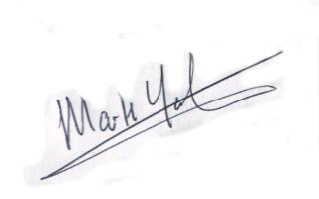

Mark Yates
Membership Secretary

VF

Le mois d’octobre nous arrive encore et déjà, avec ses images qui rapellent les scènes de Millet : des moissons, des bois flamboyants avec les couleurs d’automne. Les questions de la saison se posent: « puis-je manger ce champignon ou est-il vénéneux », « dois-je me promener dans les bois avec tous ces chasseurs qui, après un déjeuner bien arrosé se promènent, le fusil porté sur la nuque, le baril dans l’oreille du voisin. »

Et, avec tout cela, la pluie des impôts, des factures et des demandes diverses – auxquels je vais en ajouter un.

Effectivement l’année de la Royal British Legion commence le 1° octobre et voici, je vous rappelle que j’attends votre cotisation (à moins que vous soyez parmi ceux qui ont déjà réglé et que je remercie cordialement pour leur prévoyance)

Il m’est agréable, toutefois, de pouvoir vous signaler qu’après mûre réflexion, votre comité a décidé, et ceci pour la septième année de suite, de ne pas augmenter les cotisations – je me permets nonobstant de vous rappeler que les contributions au Poppy Appeal et à nos fonds administratifs - mentionnés sur le formulaire ci-joint - sont toujours les bienvenues.
Si vous perdez le formulaire de cotisation ci-joint, il est toujours possible de télécharger une copie à partir de notre site Web rblfrance.org. Sur le même site vous pouvez également:

- télécharger un formulaire de demande d'adhésion pour le cas où vous en auriez besoin,
- lire la dernière « Newsletter »,
- trouver des informations sur les déjeuners mensuels et les événements à venir, tels que le « coffee morning » à l’ambassade, la cérémonie du onze novembre à Notre-Dame ...
- publier gratuitement une annonce.
Vous trouverez le formulaire de cotisation sur la page suivante. Je vous serais reconnaissant si vous pouviez me faire parvenir votre chèque avant le 30 Octobre.

Cordialement
Mark Yates
Membership Secretary



